**Naive Bayes Intuition**

Naive Bayes classifiers are a collection of classification algorithms based on **Bayes’ Theorem**. It is not a single algorithm but a family of algorithms where all of them share a common principle, i.e. every pair of features being classified is independent of each other.

To start with, let us consider a dataset, Consider a fictional dataset that describes the weather conditions for playing a game of golf. Given the weather conditions, each tuple classifies the conditions as fit(“Yes”) or unfit(“No”) for playing golf.

|  |  |  |  |  |  |
| --- | --- | --- | --- | --- | --- |
| 0 | Rainy | Hot | High | False | No |
| 1 | Rainy | Hot | High | True | No |
| 2 | Overcast | Hot | High | False | Yes |
| 3 | Sunny | Mild | High | False | Yes |
| 4 | Sunny | Cool | Normal | False | Yes |
| 5 | Sunny | Cool | Normal | True | No |
| 6 | Overcast | Cool | Normal | True | Yes |
| 7 | Rainy | Mild | High | False | No |
| 8 | Rainy | Cool | Normal | False | Yes |
| 9 | Sunny | Mild | Normal | False | Yes |
| 10 | Rainy | Mild | Normal | True | Yes |
| 11 | Overcast | Mild | High | True | Yes |
| 12 | Overcast | Hot | Normal | False | Yes |
| 13 | Sunny | Mild | High | True | No |

The dataset is divided into two parts, namely, **feature matrix** and the **response vector**.

* Feature matrix contains all the vectors(rows) of dataset in which each vector consists of the value of **dependent features**. In above dataset, features are ‘Outlook’, ‘Temperature’, ‘Humidity’ and ‘Windy’.
* Response vector contains the value of **class variable**(prediction or output) for each row of feature matrix. In above dataset, the class variable name is ‘Play golf

**Assumption:**

The fundamental Naive Bayes assumption is that each feature makes an:

* independent
* equal

contribution to the outcome

With relation to our dataset, this concept can be understood as

* We assume that no pair of features are dependent. For example, the temperature being ‘Hot’ has nothing to do with the humidity or the outlook being ‘Rainy’ has no effect on the winds. Hence, the features are assumed to be **independent**.
* Secondly, each feature is given the same weight(or importance). For example, knowing only temperature and humidity alone can’t predict the outcome accurately. None of the attributes is irrelevant and assumed to be contributing **equally** to the outcome

**Bayes’ Theorem**

Bayes’ Theorem finds the probability of an event occurring given the probability of another event that has already occurred. Bayes’ theorem is stated mathematically as the following equation:

where A and B are events and P(B) ≠ 0.

* Basically, we are trying to find probability of event A, given the event B is true. Event B is also termed as **evidence**.
* P(A) is the **priori** of A (the prior probability, i.e. Probability of event before evidence is seen). The evidence is an attribute value of an unknown instance(here, it is event B).
* P(A|B) is a posteriori probability of B, i.e. probability of event after evidence is seen

Now, with regards to our dataset, we can apply Bayes’ theorem in following way:

where, y is class variable and X is a dependent feature vector (of size *n*) where:

Just to clear, an example of a feature vector and corresponding class variable can be: (refer 1st row of dataset)

X = (Rainy, Hot, High, False) y = No

So basically, P(y|X) here means, the probability of “Not playing golf” given that the weather conditions are “Rainy outlook”, “Temperature is hot”, “high humidity” and “no wind”.

**Naive assumption**

Now, its time to put a naive assumption to the Bayes’ theorem, which is, **independence** among the features. So now, we split **evidence** into the independent parts.

Now, if any two events A and B are independent, then,

P(A,B) = P(A)P(B)

Hence, we reach to the result:

which can be expressed as:

Now, as the denominator remains constant for a given input, we can remove that term:

Now, we need to create a classifier model. For this, we find the probability of given set of inputs for all possible values of the class variable *y* and pick up the output with maximum probability. This can be expressed mathematically as:

So, finally, we are left with the task of calculating P(y) and P(xi | y).

Please note that P(y) is also called **class probability** and P(xi | y) is called **conditional probability**.

The different naive Bayes classifiers differ mainly by the assumptions they make regarding the distribution of P(xi | y).

Let us try to apply the above formula manually on our weather dataset. For this, we need to do some precomputations on our dataset.We need to find P(xi | yj) for each xi in X and yj in y. All these calculations have been demonstrated in the tables below: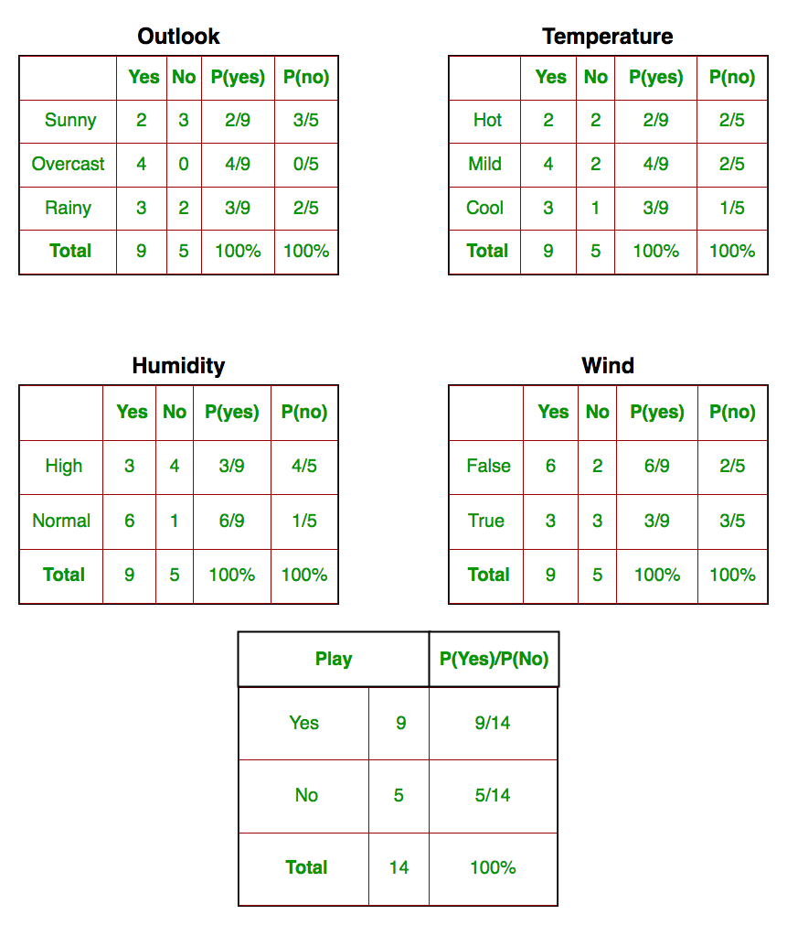

So, in the figure above, we have calculated P(xi | yj) for each xi in X and yj in y manually in the tables 1-4. For example, probability of playing golf given that the temperature is cool, i.e P(temp. = cool | play golf = Yes) = 3/9.

Also, we need to find class probabilities (P(y)) which has been calculated in the table 5. For example, P(play golf = Yes) = 9/14.So now, we are done with our pre-computations and the classifier is ready!

Let us test it on a new set of features (let us call it today):

today = (Sunny, Hot, Normal, False)So, probability of playing golf is given by:

and probability to not play golf is given by:

Since, P(today) is common in both probabilities, we can ignore P(today) and find proportional probabilities as:

and

Now, since

These numbers can be converted into a probability by making the sum equal to 1 (normalization):

and

Since

So, prediction that golf would be played is ‘Yes’The method that we discussed above is applicable for discrete data. In case of continuous data, we need to make some assumptions regarding the distribution of values of each feature. The different naive Bayes classifiers differ mainly by the assumptions they make regarding the distribution of P(xi | y).

**Gaussian Naive Bayes classifier**I:

n Gaussian Naive Bayes, continuous values associated with each feature are assumed to be distributed according to a **Gaussian distribution**. A Gaussian distribution is also called [Normal distribution](https://en.wikipedia.org/wiki/Normal_distribution). When plotted, it gives a bell shaped curve which is symmetric about the mean of the feature values as shown below:

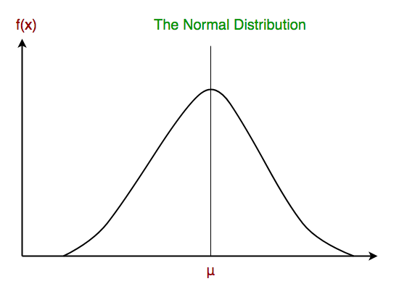

The likelihood of the features is assumed to be Gaussian, hence, conditional probability is given by: